**CSE 6363 MACHINE LEARNING**

**REPORT ASSIGNMENT 4**

**GLEN CORREIA 1001980331**

**LSTM:**

Training for LSTMs Model Loss Plot: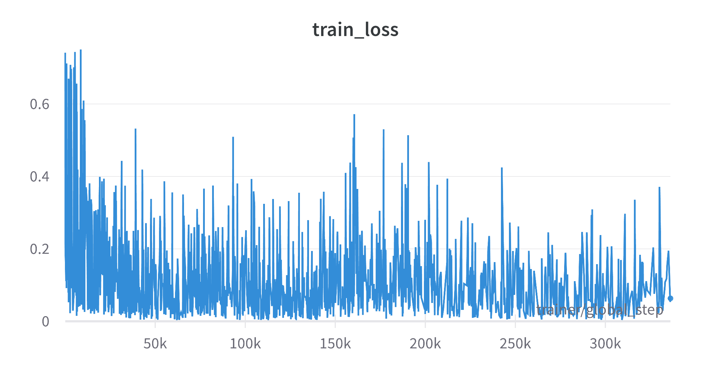

Validation for LSTMs Model Loss Plot: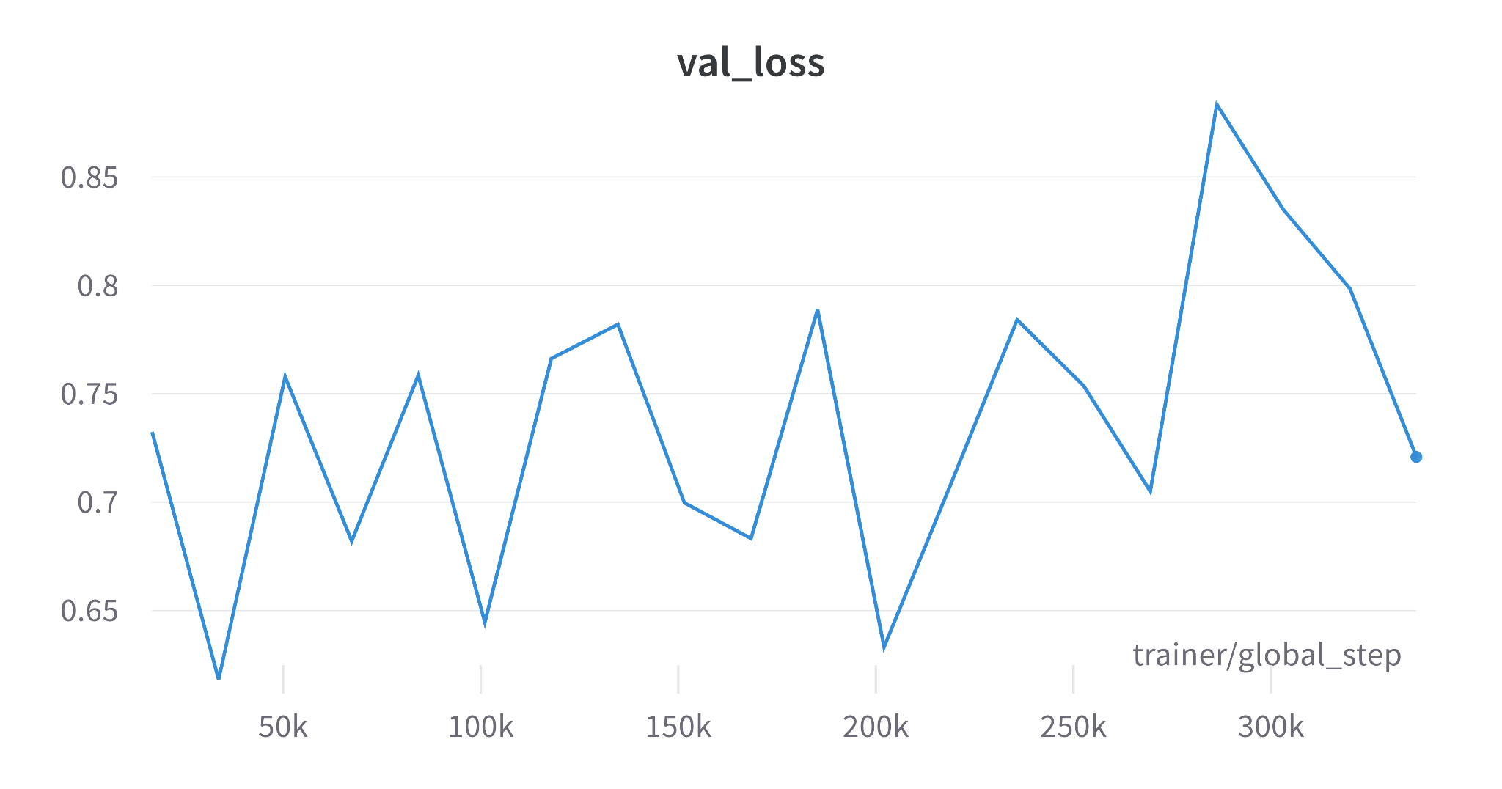

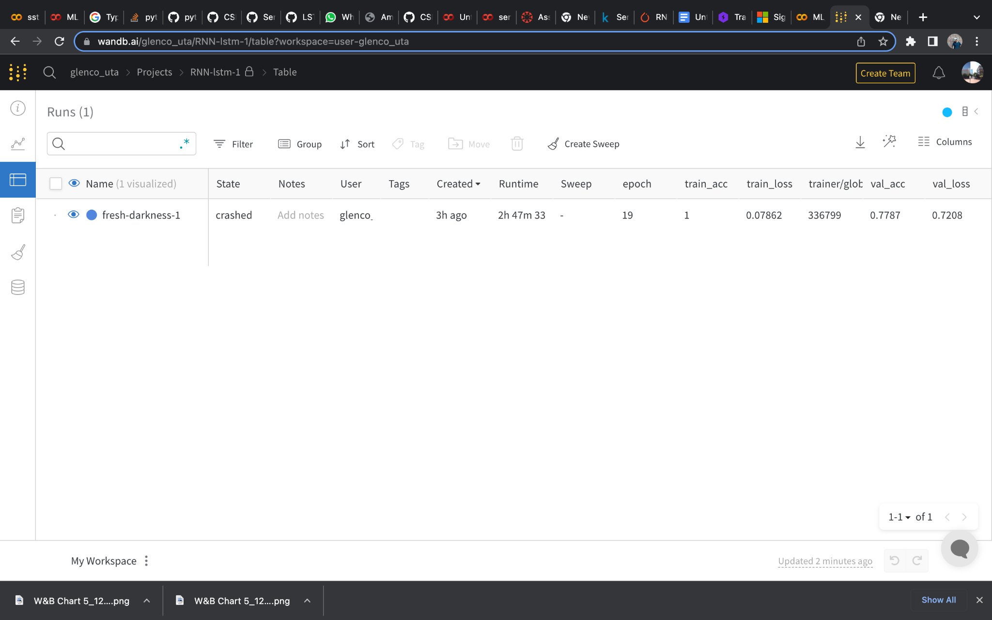

**RNN**

Training for RNN 1st Model Loss Plot: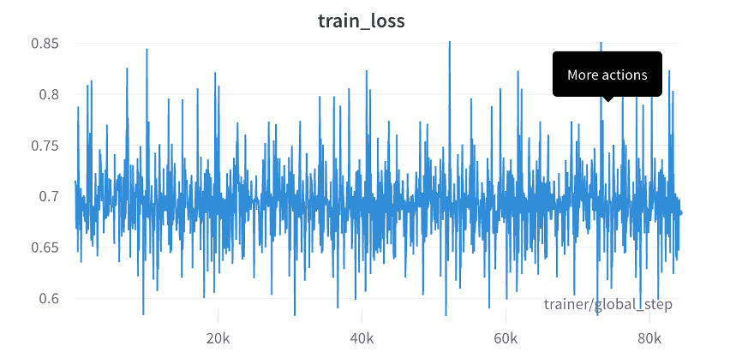

Training for RNN 2nd Model Loss Plot: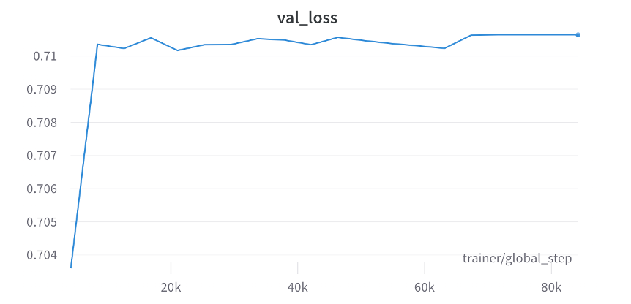

Validation for RNN 1st Model Loss Plot: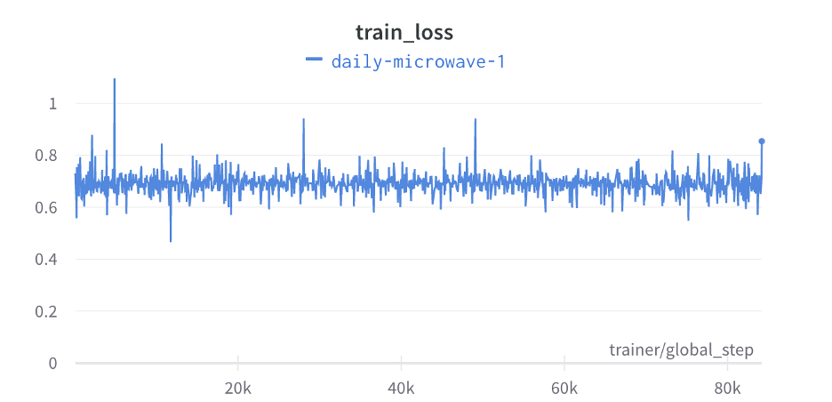

Validation for RNN 2nd Model Loss Plot :